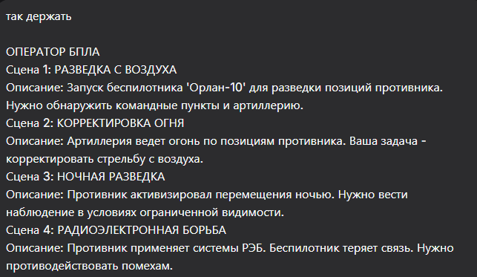
Отлично, продолжаем! Вот промты для оператора БПЛА.

Сцена 1: РАЗВЕДКА С ВОЗДУХА
Промt:
masterpiece, best quality, 8k, photorealistic, aerial reconnaissance, Russian Orlan-10 UAV launching from a portable catapult in a field at dawn. The silhouettes of two operators in the background, monitoring the launch. Flat terrain with military trucks nearby. Morning mist, soft lighting. No people visible, only their silhouettes, no faces or hands detailed.
Negative Prompt:
deformed, blurry, bad anatomy, disfigured, poorly drawn face, mutation, mutated, extra limb, ugly, poorly drawn hands, missing limb, blurry, floating limbs, disconnected limbs, malformed hands, long neck, human face, detailed face, fingers, enemy soldiers

Сцена 2: КОРРЕКТИРОВКА ОГНЯ
Промt:
masterpiece, best quality, 8k, photorealistic, first-person view from a UAV camera screen, showing a black and white aerial view of enemy artillery positions. Multiple explosions from artillery strikes visible on the ground. The silhouette of an operator's hand and arm visible in the foreground, pointing at the screen. No identifiable features.
Negative Prompt:
deformed, blurry, bad anatomy, disfigured, poorly drawn face, mutation, mutated, extra limb, ugly, poorly drawn hands, missing limb, blurry, floating limbs, disconnected limbs, malformed hands, long neck, human face, detailed face, full person, colorful image

Сцена 3: НОЧНАЯ РАЗВЕДКА
Промt:
masterpiece, best quality, 8k, photorealistic, night operations, a dimly lit mobile command post. Green and black thermal imaging feed from a UAV displayed on multiple monitors, showing heat signatures of vehicles moving at night. The silhouettes of operators huddled around the screens. Dark atmosphere, focused on the technology.
Negative Prompt:
deformed, blurry, bad anatomy, disfigured, poorly drawn face, mutation, mutated, extra limb, ugly, poorly drawn hands, missing limb, blurry, floating limbs, disconnected limbs, malformed hands, long neck, human face, detailed face, fingers, daytime, bright lights

Сцена 4: РАДИОЭЛЕКТРОННАЯ БОРЬБА
Промt:
masterpiece, best quality, 8k, photorealistic, electronic warfare scene, interior of a command vehicle. Monitor screens showing static and "SIGNAL LOST" warnings. The silhouettes of operators urgently working on control panels and radio equipment. Tense atmosphere, red emergency lighting. No people details, only shadows and shapes.
Negative Prompt:
deformed, blurry, bad anatomy, disfigured, poorly drawn face, mutation, mutated, extra limb, ugly, poorly drawn hands, missing limb, blurry, floating limbs, disconnected limbs, malformed hands, long neck, human face, detailed face, fingers, calm, stable connection

Сцена 5: ФИНАЛЬНАЯ РАЗВЕДКА
Промт:
masterpiece, best quality, 8k, photorealistic, final reconnaissance mission, dawn over a war-torn landscape. A large tactical UAV (like "Forpost") flies high in the sky. First-person view from the ground control station: multiple monitors show a clear aerial feed, pinpointing the last enemy command vehicles hiding in a forest edge. The silhouettes of exhausted but focused operators in the dimly lit vehicle. A sense of tense anticipation.
Negative Prompt:
deformed, blurry, bad anatomy, disfigured, poorly drawn face, mutation, mutated, extra limb, ugly, poorly drawn hands, missing limb, blurry, floating limbs, disconnected limbs, malformed hands, long neck, human face, detailed face, fingers, destroyed UAV, celebration

